Administration of Criminal Justice Monitoring Committee (ACJMC) - Federal

Monthly Newsletter – Volume 1, Issue 4.
April 2022

Inside this Issue
- Editor’s Note.
- Message from the Executive Secretary’s Desk.
- Key Developments in the Operations of some Agencies Implementing the ACJA 2015.
- Article – Remand Proceedings and Recent Developments in the FCT.
- ACJMC’s Activities and Photo Gallery.

- Message from the Executive Secretary’s Desk
- Editor’s Note

Maxwell Ekor (PhD)

The issue of Remand Proceedings and its management is one of the key areas in the supervision of the criminal justice system. The Administration of Criminal Justice Committee (ACJMC) thus devotes quality time and resources at ensuring the effective monitoring of custody management system in Nigeria.

The article section of this edition of the ACJMC newsletter hence focuses on ‘Remand Proceedings and Recent Changes in Managing Remand Proceedings in the FCT’. Written by Barrister Joshua Dada, the well articulated piece provides informative and educative discussion of the subject matter.
- Key developments in the operations of some agencies implementing the ACJA 2015.
System

In a related activity, the ACJMC Police Duty Solicitors Scheme (PDSS), led by Barrister Genevieve Johnson, held an enlightenment workshop, for police officers on custody records and management.

Also contained in this publication, which readers will find interesting, are the highlights of successes of some government agencies implementing the ACJA 2015, as well as the main activties that the ACJMC carried in the month under review.
Barrister Sulayman Dawodu

Dear distinguished partners and stakeholders, the entire team of the ACJMC Secretariat led by my humble self, once again thank you for your untiring collaboration and support as we collectively work for a better criminal justice system in Nigeria.

I wish to reinforce the fact that because of the importance of remand proceedings, the ACJMC has continued to engage with stakeholders on how the relevant sections of the ACJA 2015 relating to prisons management can be adhered to.

It is my candid opinion that the article on Remand Proceedings by Barrister Joshua Data will not only be valuable to the officers and men of the law enforcement agencies, but also to all stakeholders who desire to see better treatment of suspects and inmates in the different places of detention.
In the month under review, the Economic and Financial Crimes Commission (EFCC) was succesful in its continued prosecution of criminal cases.
The ACJMC is in constant discussions with the relevant officers of the Commission to ensure that key provisions of the ACJA 2015 are complied with.
Some of the main activties of the EFCC in the period under review are as follows:
- The Commission arrested the former Governor of Anambra state Willie Obiano shortly after handing over to a Chukwuma Soludo as the new governor. However, in the current month, it disagreed with a court directive that the travel documents of the former governor be released to enable him travel abroad for medical treatment.

Because cases involving politically-exposed persons tend to delay, the ACJMC hopes that the EFCC will effectively conclude its investigations to enable the speady completion of the case.

- After several years of prosecuting a former Permanent Secretary at the Ministry of Interior, Anastasia Daniel-Nwobia alongside Senator Abba Morro, former Minister of Interior; Femi O Alayebami, a Deputy Director in the Ministry; one Mahmood Ahmadu (at large), and Drexel Tech Nigeria Ltd., on charges of fraud arising from the controversial 2014 Nigeria Immigration Service recruitment, Justice Nnamdi Dimgba of the Federal High Court in Abuja on April 7 convicted the former Permanent Secretary.

With the rights of appeal window still available, the case may still drag on for some time and this elongated timeline is at variance with the speady trial provisions of the ACJA 2015.

- The EFCC successfully closed the corruption case to the tune of N22.9 billion involving a former Assistant Director in the Police Pension Office, John Yakubu Yusuf as the Supreme Court on April 13, 2022, affirmed the six years jail term imposed on him by the lower court. In addition, apex court also ordered the convict to refund the N22.9b to government coffers.

The ACJMC believes this is a vital milestone for the Commission in its effort at taming corruption in the public service. The timeline for completing cases with such huge amounts remains an issue and the ACJMC hopes that its continued advocacies will improve the system.

- In Kano State, the EFCC on April 13, 2022 got a Court of Appeal judgement which set aside the ruling of the Federal High Court that discharged and acquitted a Kano State gubernatorial candidate, Abdulsalam Sale Abdulkarim Zaura. The Commission had accused Zaura of defrauding a Kuwaiti national of the sum of $1,320,000 (One Million Three Hundred and Twenty Thousand Dollars) under the pretext that he is into real estate development in Dubai, Kuwait and other Arab countries.

- The EFCC also successfully got an Appeal Court ruling in Lagos on April 13, 2022 which dismissed the decision of a Federal High Court in the case involving a former Executive Director, Projects, Niger Delta Development Commission, Tuoyo Omatsuli, over alleged case of money laundering to the tune of Three Billion, Six Hundred and Forty-five Million Naira (N 3, 645, 000,000).

The National Agency for the Prohibition of Trafficking in Persons (NAPTIP) continued to take internal and collaborative measures aimed at strenthening its operations.

In the month under review the Director-General Mrs. Beatrice Jedy-Agba at a meeting of stakeholders for the formal presentation and dissemination of the Agency's institutional and operational assessment carried out by independent consultants hinted that proper collaboration amongst Law Enforcement Agencies remains the panacea for effective crime prevention in Nigeria. According to her, many crimes are related and so needs closer relationship among Law Enforcement Agencies to deal with them.
The meeting was attended by representatives of the United Nations Office on Drug and Crimes (UNODC), European Union, Nigerian Immigration Service, Nigerian Police Force, Federal Ministry of Labour and Productivity, Ministry of Women Affairs, and the Network of Civil Society Organization against Child Trafficking Abuse and Labour (NACTAL).
The ACJMC is impressed with the collaborative measures by NAPTIP as it is in line with the Committee’s tactical approach for improving the criminal justice system in its Change Management Framework.
The National Drugh Law Enforcement Agency (NDLEA) remained active in the review period owing to its recording of successes in its operations some of which are as follows:
- Remand Proceedings and Recent Changes in Managing Remand Proceedings in the FCT

- The Agency provided statistics of its successes in terms of prosecutions and convictions for the first quarter of 2022. It revealed that a total of 3,359 arrests were made, and 65,915.891 kilograms of assorted drugs seized between January and March 2022. Also, about 677 traffickers were convicted within the same period.

The number of convicted offenders of 677 is only 20% of the total arrests of 3,359 made in the quarter. The ACJMC considers this low conviction rate a drag on the criminal justice system and hopes that the NDLEA will be more diligent in its investigation and prosecution of arrested suspects.

- The NDLEA had a virtual meeting with South Africa’s Directorate for Priority Crime Investigation, with the understanding of an improved collaboration between Nigeria and South Africa to tackle the menace of drug trafficking between the two countries.

The ACJMC believes that this is a vital initiative given the heavy traffic of drug and drug related movements between the two countries. However, it is hoped that the collaboration will have positive effects on the timeline for prosecuting offenders.

- In terms of arrests, the Agency apprehended a notorious queen of drug cartel supplying psychoactive substances to traffickers in Taraba state, named Lami Mai Rigima after being on its wanted list. The suspect came under searchlight when a number of traffickers arrested in 2021 and early 2022 fingered her as their supplier.

In a related development, the Agency announced the arrest of a Nigerian “billionaire drug baron” and Chairman of Mallinson Group named Chief Afam Mallinson Emmanuel Ukatu. The suspect is said to be behind the N3 billion Tramadol deal involving the suspended police chief, Abba Kyari.
Barrister Joshua Dada
- Background
When a person is suspected to have committed an offence and he/she is arrested; there is sometimes not enough evidence by the arresting institution at the material time of the arrest capable of sustaining trial or grounding conviction if the suspect were immediately arraigned and the prosecution were to open its case.
It is for this reason and for other investigative purposes that the Police and other arresting institutions make applications to the court seeking for an order to detain the suspect beyond the legally permissible time limit for custody which is 48 hours.
This process and the grant of the order and other sundry factors around the application and enforcement of these orders are commonly referred to as ‘Remand Proceedings’.
- Introduction
The Administration of Criminal Justice Act (ACJA) 2015 was enacted for the purpose of reforming and standardizing the criminal justice sector and the practices of stakeholders in line with international best practices and global standards. The ACJA thus has innovative provisions that address the poor state of affairs that existed in the criminal justice system before its advent. One of such areas which the provisions of the ACJA deal with is pre-trial remand.
- Application of Remand Provisions in FCT
History of the Pre-Trial Remand in the FCT
Prior to the ACJA 2015, pre-trial remand in the FCT was a nightmarish situation at least. An arrested person would typically be held in the custody of the Police or Prison without any proper charge or arraignment but simply by an application made by the Police and granted by a Magistrate to detain the suspect until the investigation of case is concluded.
This sort of practice was called ‘holding-charge’ and it led to the very lengthy and abusive holding of suspects who were most times forgotten in the places of detention because there was no return date on the order made to detain them neither was the order typically followed up by the issuing authority.
Intervention by the Judiciary
In a bid to stop this practice, the Chief Judge of the FCT admonished Magistrates to abstain from issuing or granting this orders and should rather direct the applicants to seek an order of arraignment from a court which has jurisdiction to hear the case so that before the order is sought the case in question can either be formally filed in the court and the suspect arraigned or the case is at least brought within the knowledge of a court which has competence to hear and try the case.
- Challenges with this Intervention
Although this can be deemed as a brilliant move from the Judiciary in dealing with this situation and ameliorating the possibilities of indiscriminate and very lengthy detentions, it birthed two major problems;
- Remand Orders Sought from Area Courts - The first problem that was experienced with this intervention by the Judiciary which admonished Magistrates not to grant these orders again was that the Police and other arresting institutions now sought for remand orders from Area Court since the magistrates declined to grant same. This posed a huge challenge to the criminal justice sector and was very problematic for the following reasons;
i. Jurisdiction: The criminal jurisdiction of the Area Courts in the FCT is still being debated and out of it and there is no certain pronouncement or finality from the apex court that has addressed this issue of its jurisdiction save two conflicting judgments of courts of co-ordinate jurisdiction in the FCT.
ii. Qualification of Area Court Judges: Beyond the problem of Jurisdiction in the Area Court which goes to the root of their propriety to grant these orders; the issue of qualification of the Area Court Judges also comes to view as there are some Area Court Judges that are not even qualified legal practitioners and may not inherently appreciate the complications of criminal litigation by virtue of their seeming lack of training for this purpose.
iii. Coordination and Supervision: Lastly, the Area Courts in the are arguably not as coordinated and supervised as the Magistrate Courts thus sharp practices can run riot on the court and the idea of following up of orders when they are granted may not be readily implemented.
- Lengthy Detentions
For Police Divisions and arresting institutions who did not bother seeking orders to remand suspects pending the conclusion of investigations from the Area Courts, they just kept the suspects in their detention facilities until they were done with their investigation. This practice also raises issues such as prolonged custody of suspects beyond the legally permissible time limit of 48 hours; the violation of the suspects’ right; the violation of extant statutes on torture by the defaulting Police Division and arresting institutions.
- Post ACJA Remand Applications in FCT
After the enactment of the ACJA 2015, it was clear from the pages of the ACJA, particularly Part 30 – that the ACJA had made a deliberate departure from the old order of things by specifically providing for the method of seeking for remand. It also provided for the maximum number of days any remand order sought for can remain operational. It provides further for the maximum number of times an application for remand can be sought or granted by the courts. This part also makes provisions for the things to be considered by the court when granting an application for remand.
With these provisions in the ACJA, the whole gamut of pre-trial remand has been sufficiently covered thus the legal framework for the regulation of remand order exists which clearly rules out the possibility of uncertainty or abuse.
- Intervention of the ACJMC
After the enactment of the ACJA 2015, the Administration of Criminal Justice Monitoring Committee (ACJMC) was established under s. 469 of the Act to ensure the full implementation of the Act by stakeholders and institutions given responsibilities under it.
Unfortunately, the provisions relating to remand orders were not immediately implemented after the enactment of the ACJA and it has taken the intervention of the ACJMC to ensure the application of the remand order provisions.
The ACJMC intervened in the following ways.
1. Engagement with and sensitization of stakeholders on the provisions of the ACJA relating to pre-trial remand orders.
2. Recommending the express permission of the Chief Judge of the FCT to Magistrates to grant remand orders following the provisions of the ACJA giving them such powers.
3. Recommending the use of a remand order register by all courts receiving and granting remand applications.
4. Training of Judges, Magistrates and Court support staff on the methods and processes of remand applications and follow-up mechanisms for the orders granted. Such mechanisms include the use of s.34 judicial oversight visitation and keeping of remand order registers.
5. Supporting the drafting and development of Practice Directions and Guidelines on Remand Orders for the FCT High Court.
- Advantages of ACJA to Remand Orders
1. It sets out the method by which any pre-trial remand order is to be sought for so that the Police and other arresting institutions are guided on how to make an application for a pre-trial remand order.
2. It sets out factors to be taken into consideration by a Judge or Magistrate before granting the application for pre-trial remand. S. 294
- Main ACJMC Activities in the month
3. It clearly identifies the persons responsible for granting a remand order and makes no mention of Area Court Judges thus putting an end to the debate as to the propriety of an Area Court to grant pre-trial remand orders. S. 293.
4. It identifies responsible persons needed for the supervision of the grant of remand orders when they are made. S. 293 – S. 299
5. It sets out exact timelines, conditions and limits the number of days a remand order can last before it is returnable and the number of times an application for remand can be made. S. 296
6. It gives the Magistrate or Judge the power to admit the remand suspect to bail or discharge the suspect either suo motu or by an application for same. S. 295, S. 296(6).
7. It provides a supervisory mechanism under s. 34 which mandates the monthly conduct of oversight visitation to Police Divisions and other places of detention (other than the prisons) by Judges and Magistrates which in turn forestalls the possibility of keeping suspects in detention without any order from the court for that purpose.
If such situation were to exist during any oversight visit, the Judges and Magistrates are empowered by the same section to discharge the suspect, order his immediate arraignment or admit him to bail (whether or not bail had been granted or refused him by the arresting institution). S. 34
- Conclusion and Recommendation
Whilst the enactment of the ACJA 2015 has put the FCT within the right legal trajectory to deal with the issue of pre-trial remand; it still behoves on the stakeholders like the Judges, Magistrates, Arresting Institutions, Correctional Service etc. to take upon themselves the responsibilities and obligations imposed on them by the ACJA and work audaciously to fully implement these provisions.
In this wise, the gory experiences of holding charge in the FCT would be truly a thing of the past and the criminal justice system would fully enjoy (within the bounds of law); all the advantages which the inclusion of pre-trial remand in our legal system sought to communicate to the stakeholders.
It was, as usual, an eventful month for the ACJMC and the highlights of its activities in the period are listed as follows:
- ACJMC Kastina Support between April 6 – 8, 2022.
- Training of Police DPOs on S. 33 reporting obligation on April 13th and 14th at the Conference hall of the Judicial Service Committee.
- Oversight Visitation to Apo Police Station with his Worship Majid on April 12th 2022.
- Training of Oversight Visitation to Police and other law enforcement agencies held in Jos, Plateau State between April 21st- 22nd 2022 with DCR Magistrate Celestine Odo and Moyo Boluwade.
- UNODC Support of BI-Monthly Counter Terrrosrim Workshop at Valencia hotel on April 26, 2022.
- Oversight visit to Bwari Police Station - April 14, 2022.
- Oversight visit to Gwarimpa and Kubwa Police Stations on the April 28, 2022.
ACJMC Police Duty Solicitors Scheme (PDSS)
The main milestones achieved by the ACJMC PDSS in the month under review are as follows:

Office Space
- A new Secretariat was acquired on the 1st of April 2022, and it is located at 139 SB Abubarka NAF Valley, Asokoro. The new office is the ACJMC Annex, which is properly the PDSS/ CDSS Secretariat.

- With a settled accommodation, it is expected that the PDSS team will now be more settled and coordinated in carrying out its activities.
Workshop on ACJA 2015
- On the 13th and 14th of April 2022; the ACJMC PDSS, PWAN PDSS, DPOs and DCOs of different Police Divisions in the FCT had a workshop on Section 33 of the ACJA 2015.

- The session was facilitated by Mr Joshua Dada and the presentation focused on the legal obligations of the Police to make a monthly report of all suspects who are arrested without a warrant to a Supervising Magistrate within their jurisdiction.

- Furthermore, the workshop examined Sections 15, 30 and 33 of the ACJA 2015 and also prescribed a reporting format for making returns to the Supervising Magistrate on the last day of every month.

- Some of the challenges identified in complying with reporting obligations were: (a) Lack of or insufficient magisterial visits; (b) Nonexistent facilities and gadgets for preparing reports at the stations e.g., functional computers, copiers etc., and (c) the training gaps identified with the Investigating Police Officers who supply information to be presented in the reports.
Appraisal meeting
- In the March Appraisal meeting held at the PDSS Secretariat; all the Duty Solicitors present acknowledged that they have so far had good working relationships with the Police Officers at their various stations.

- Some challenges nevertheless have been recurrent in the past month such as the Police going on random raids at night and making arrests and detention of persons for no specific criminal causes.

- A duty solicitor mentioned having an extremely short and monitored time to interact with detainees which proved ineffective in gleaning the relevant information for action, while other solicitors complained of insufficient number of Police prosecutors and lack of sureties in their divisions, frustrating the efforts of the Police to comply with the provisions of ACJA 2015.

- It was also noted that Police Officers complain of paucity of funds for their overall maintenance and in several instances have used this as an excuse for the widespread extortion of monies from both complainants and suspects, while the concept of free bail becomes increasingly farfetched in the circumstances.

- Some of the suspects charged to court do not have legal representations which result to unnecessary detentions in certain instances.
Medical Safety Measures
- The PDSS team received approval to distribute First Aid Kits to fifteen (15) Police Divisions and the expectation is that the exercise will be perfected subsequently while plans are ongoing to launch of the Court Duty Solicitor Scheme.
Photo Gallery

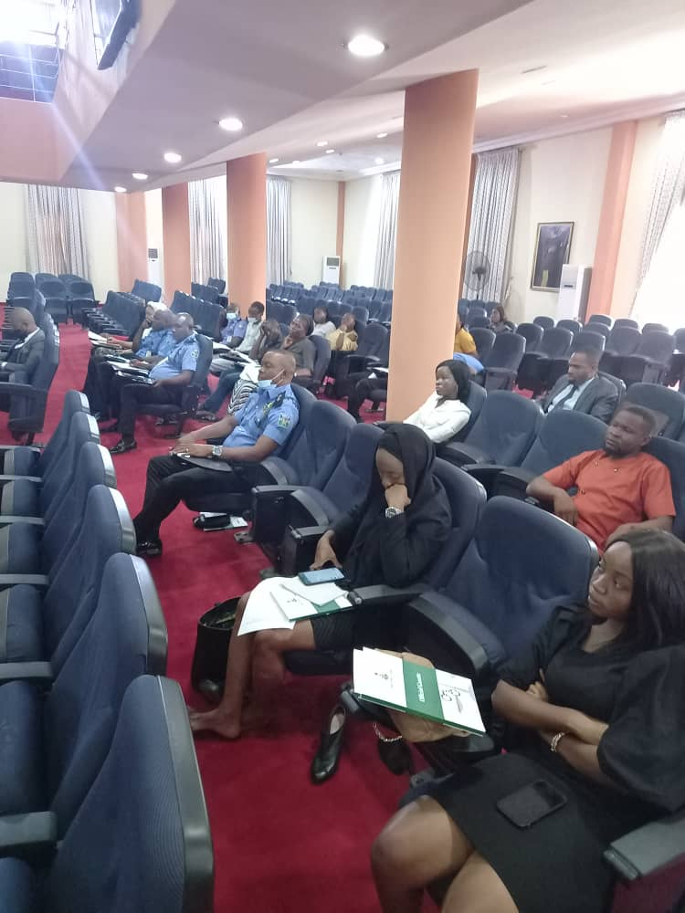

Oversight Visitation to Bwari Police
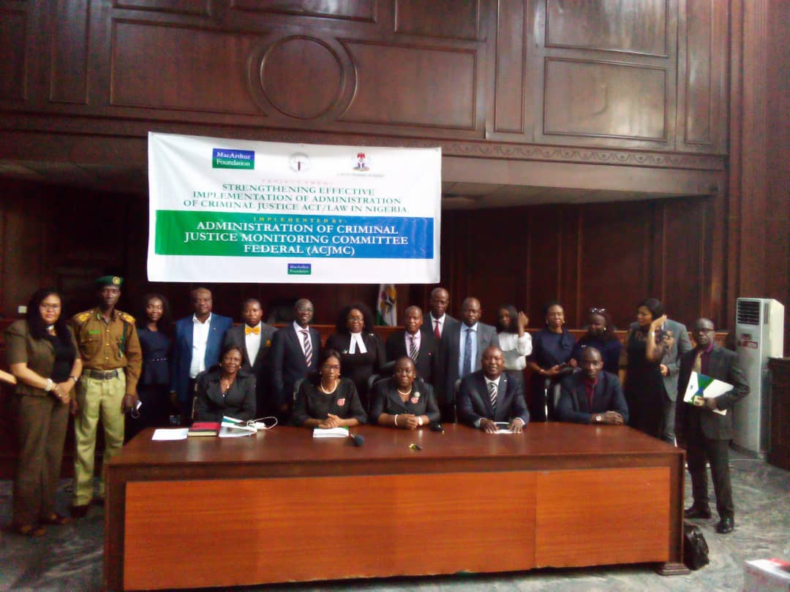

Support for Rivers State ACJMC

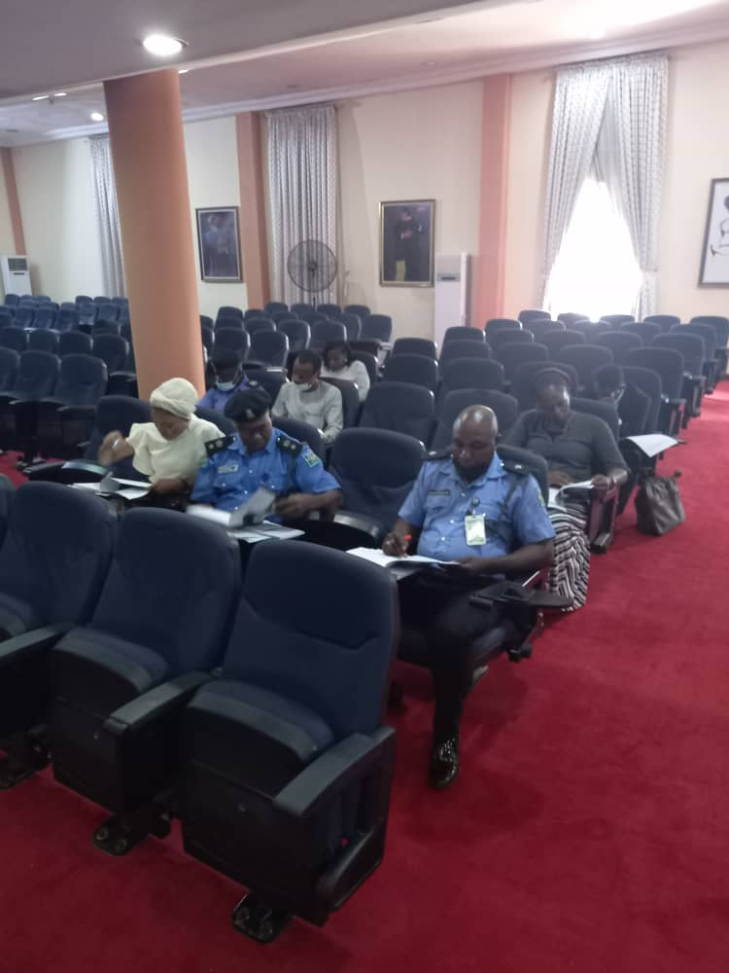

S.33 Training of DPOs and Solicitors of PDSS

S.33 Ttraining of DPOs and Solicitors of PDSS

Support for Yobe State ACJMC

Support for Oyo State ACJMC

Quote of the Month

“Criminal justice" is what happens after a complicated series of events has gone bad. It is the end result of failure--the failure of a group of people that sometimes includes, but is never limited to, the accused person.”
Paul Delano Butler

About the ACJMC Newsletter
- This newsletter is a publication of the Administration of Criminal Justice Monitoring Committee (ACJMC) Secretariat.
- The goal is to inform and educate the criminal justice stakeholders and the public about the ACJMC’s activities.
- The views expressed in the guest article section are entirely those of the author.
- For more information, please contact the Executive Secretary via sulaydawodu@yahoo.com or 09094688542.

